Dokumentasi Praktikum PBO 10

Mata Kuliah : PBO - TI - S1

Pertemuan : 10

NIM : A11.2021.13254

Nama : Yohanes Dimas Pratama

**Contoh Program Abstract Class**

Hasil Program:

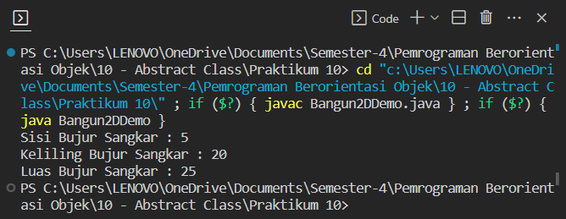

Code Program:

*BujurSangkar.java

public class BujurSangkar extends Bangun2D{

    private int sisi;

    public BujurSangkar(int sisi) {

        this.sisi = sisi;

        System.out.println("Sisi Bujur Sangkar : " + sisi);

    }

    public void cetakLuas() {

        int luas = sisi * sisi;

        System.out.println("Luas Bujur Sangkar : " + luas);

    }

    public void cetakKeliling() {

        int keliling = 4 * sisi;

        System.out.println("Keliling Bujur Sangkar : " + keliling);

    }

}

*Bangun2DDemo.java

public class Bangun2DDemo {

    public static void main(String[] args) {

        BujurSangkar bs = new BujurSangkar(5);

        bs.cetakKeliling();

        bs.cetakLuas();

    }

}

**Latihan 1**

Hasil Program:

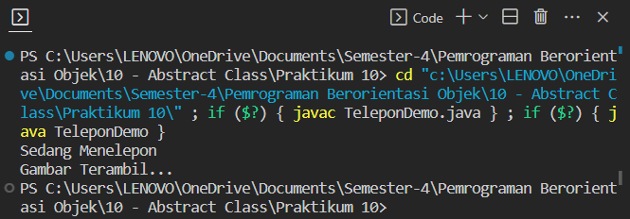

Code Program:

*TeleponDemo.java

interface Kamera {

    public void setPixel(float pixel);

    public void ambilGambar();

}

interface Radio {

    public void setGelombang(String gel);

}

class Telepon {

    protected long nomor;

    public void telpon() {

        System.out.println("Sedang Menelepon");

    }

}

class Handphone extends Telepon implements Kamera, Radio {

    private String gelombang;

    private float pixel;

    public void ambilGambar() {

        System.out.println("Gambar Terambil...");

    }

    public void setGelombang(String gel) {

        this.gelombang = gel;

    }

    public void setPixel(float pixel) {

        this.pixel = pixel;

    }

    public void setNomor(long no) {

        this.nomor = no;

    }

}

public class TeleponDemo {

    public static void main(String[] args) {

        Handphone hp = new Handphone();

        hp.setNomor(8183434);

        hp.telpon();

        hp.setPixel(1024);

        hp.ambilGambar();

        hp.setGelombang("FM 101.2");

    }

}

**Latihan 2**

Hasil Program:

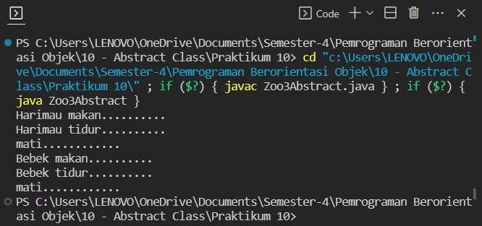

Code Program:

*Zoo3Abstract.java

abstract class Binatang { // abstract class

    abstract void makan(); // method abstract

    abstract void tidur();

    void mati() {

        System.out.println("mati............");

    }

}

class Harimau extends Binatang {

    void makan() {

        System.out.println("Harimau makan..........");

    }

    void tidur() {

        System.out.println("Harimau tidur.......... ");

    }

}

class Bebek extends Binatang {

    void makan() {

        System.out.println("Bebek makan..........");

    }

    void tidur() {

        System.out.println("Bebek tidur..........");

    }

}

public class Zoo3Abstract {

    static void test(Binatang a) {

        a.makan();

        a.tidur();

        a.mati();

    }

    public static void main(String[] a) {

        Harimau macan = new Harimau();

        Bebek duck = new Bebek();

        test(macan);

        test(duck);

    }

}

**Latihan 3**

Hasil Program:

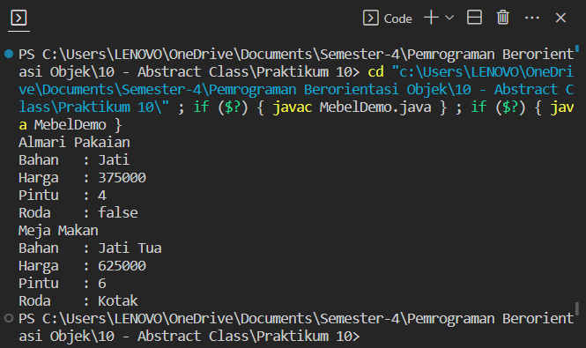

Code Program:

*MebelDemo.java

class Mebel {

    int harga;

    String bahan;

}

class Almari extends Mebel {

    boolean roda;

}

class Meja extends Mebel {

    int jmlkaki;

}

class MejaMakan extends Meja {

    int jmlKursi;

}

interface Discountable {

public void discount(int harga);

}

class MejaTamu extends Meja implements Discountable {

    String bentukKaca;

    public void discount(int harga) {

        this.harga = (harga) - ((int) (harga * 0.5));

    }

}

class AlmariPakaian extends Almari implements Discountable {

    int jmlPintu;

    public void discount(int harga) {

        this.harga = (harga) - ((int) (harga * 0.5));

    }

}

class AlmariMakan extends Almari implements Discountable {

    int jmlRoda;

    public void discount(int harga) {

        this.harga = (harga) - ((int) (harga * 0.5));

    }

}

public class MebelDemo {

    public static void main(String[] args) {

        AlmariPakaian almariPakaian = new AlmariPakaian();

        almariPakaian.bahan = "Jati";

        almariPakaian.harga = 750000;

        almariPakaian.jmlPintu = 4;

        almariPakaian.roda = false;

        almariPakaian.discount(almariPakaian.harga);

        System.out.println("Almari Pakaian");

        System.out.println("Bahan\t: " + almariPakaian.bahan);

        System.out.println("Harga\t: " + almariPakaian.harga);

        System.out.println("Pintu\t: " + almariPakaian.jmlPintu);

        System.out.println("Roda\t: " + almariPakaian.roda);

        MejaTamu mejaMakan = new MejaTamu();

        mejaMakan.bahan = "Jati Tua";

        mejaMakan.harga = 1250000;

        mejaMakan.jmlkaki = 6;

        mejaMakan.bentukKaca = "Kotak";

        mejaMakan.discount(mejaMakan.harga);

        System.out.println("Meja Makan");

        System.out.println("Bahan\t: " + mejaMakan.bahan);

        System.out.println("Harga\t: " + mejaMakan.harga);

        System.out.println("Pintu\t: " + mejaMakan.jmlkaki);

        System.out.println("Roda\t: " + mejaMakan.bentukKaca);

    }

}